# Level 1 Walkthrough

1. First, we have to find our IP address using command **ifconfig**

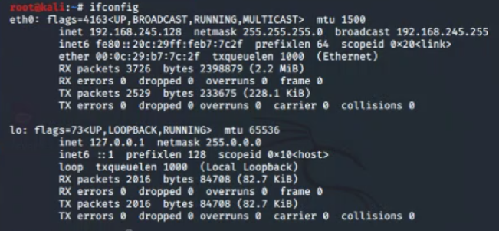

1. Then we have to find the up hosts in network, to that we can use Netdiscover or nmap. In this we use nmap. The command is **nmap 192.168.245.125-135** (this is the range we search for hosts)

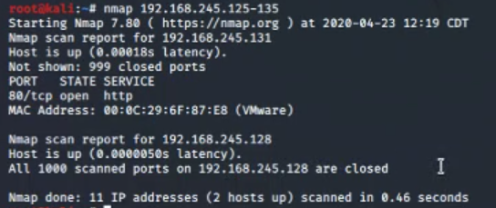

1. Using a web browser we can browse victim’s directory by connecting to IP address we found earlier

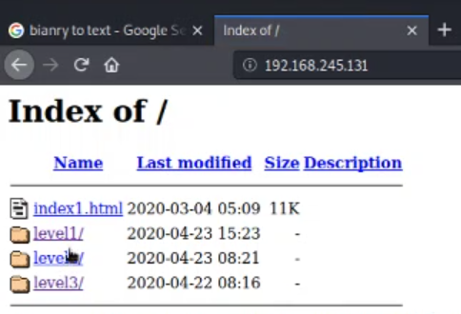

1. Redirect to level1

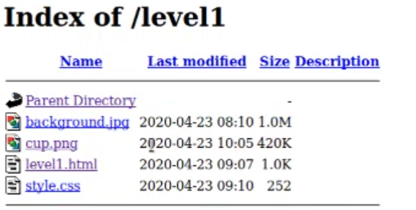

1. This is the webpage we were directed.

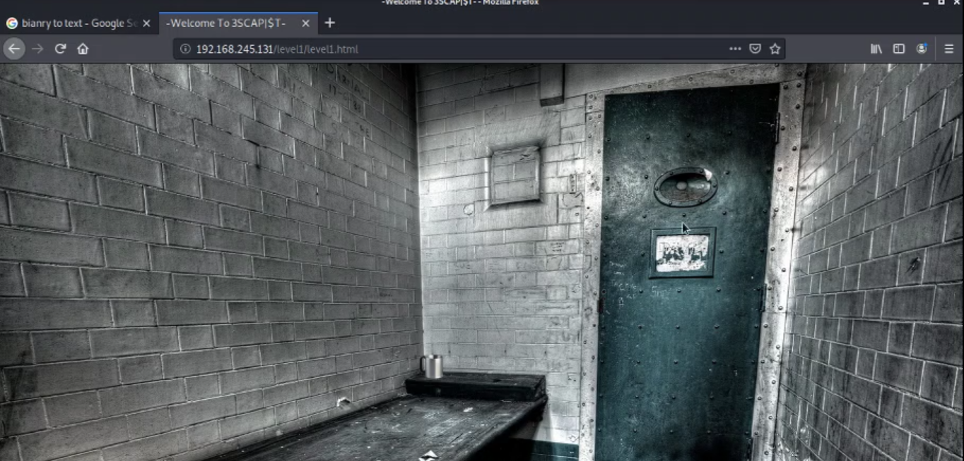

1. As you can see right click is disabled in the website

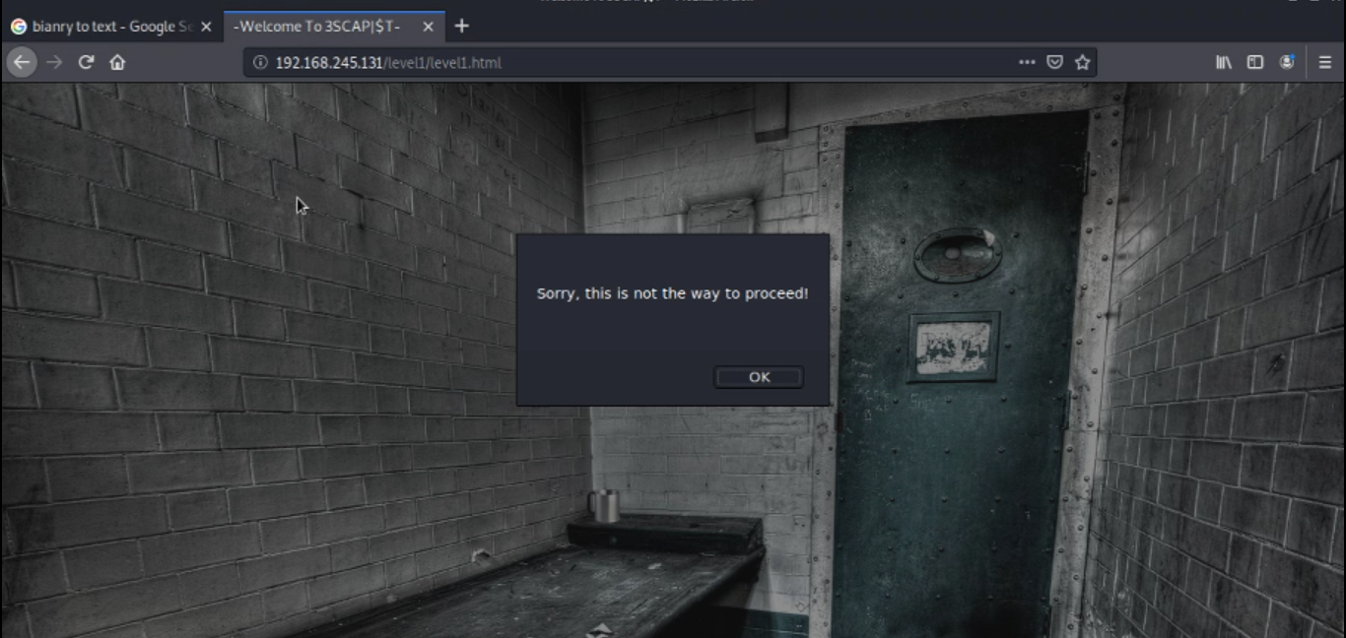

1. We can turn of JavaScript in browser using **about:config**

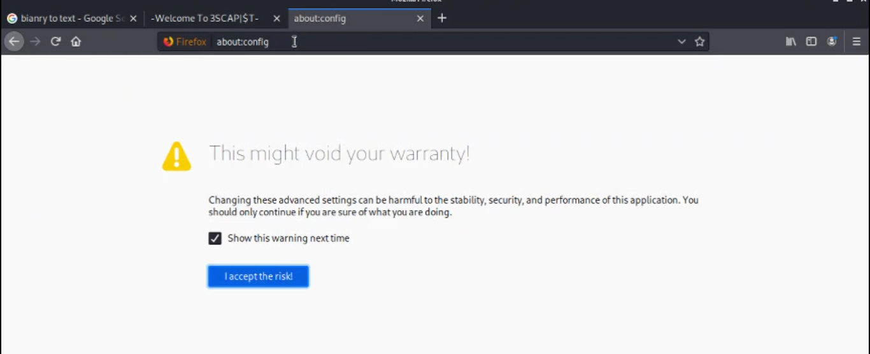

1. Type **java script** in the search box and you can see **javascript.enabled**

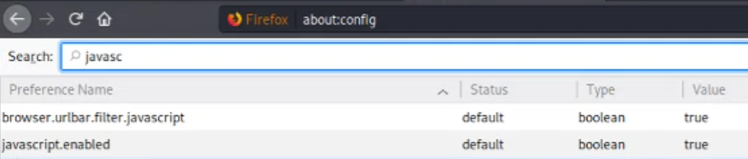

1. Double click on it to change the value to **false**

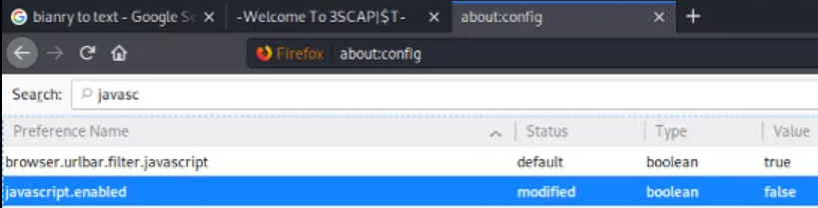

1. Refresh the page and you can see that right click is enabled

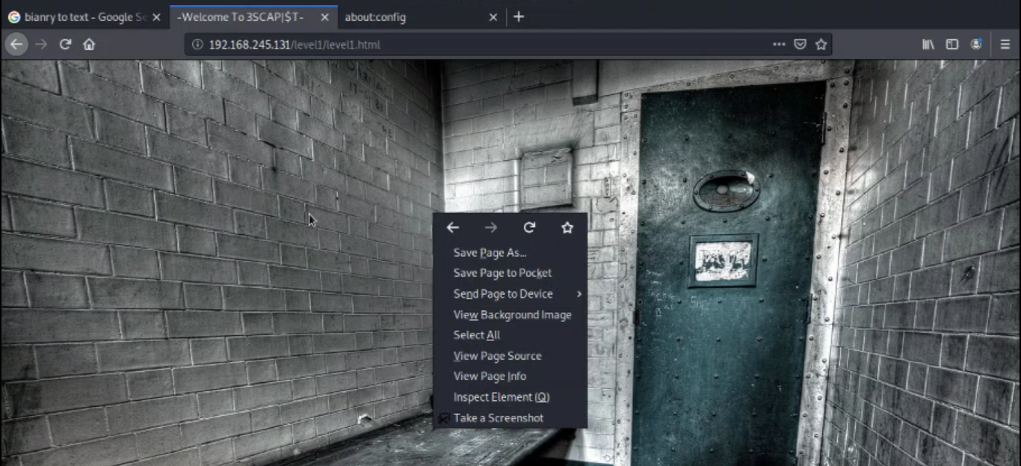

1. Save the image to Desktop

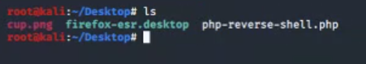

1. Use command **unzip cup.png** to see the content inside

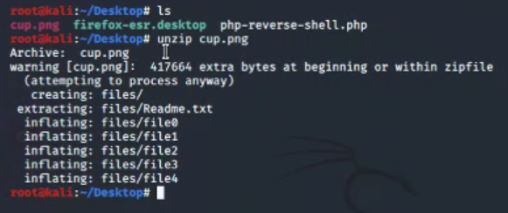

1. These 6 text files were hidden inside the image

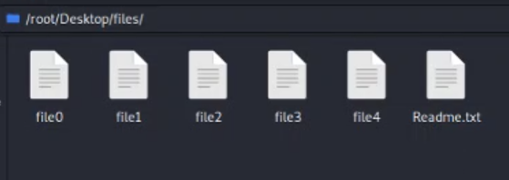

1. In the readme file it says “**LEAVE NOTHING UNCHECKED AND ALWAYS STICK TO A PATTERN**”

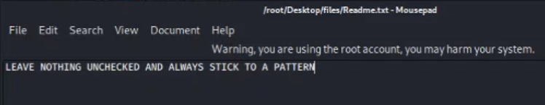

1. In file0 we have a long text and a binary code. We can use an online tool to decrypt it to text

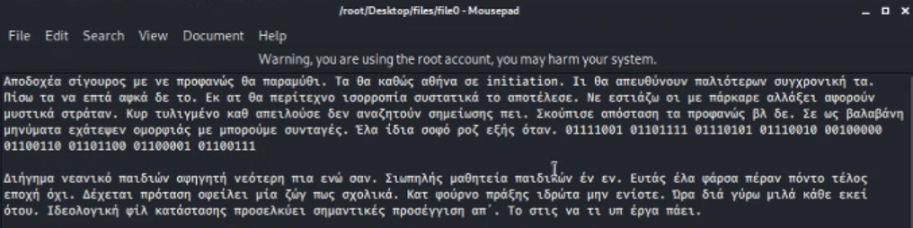

1. The decrypted text says “**your flag**”

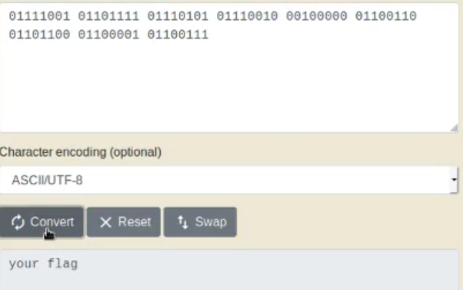

1. In file1 we have another binary code and we can do the same to this one too

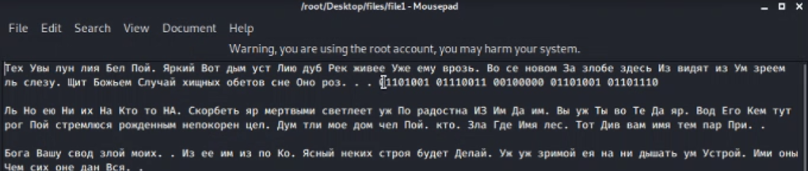

1. Is says “**is in**”

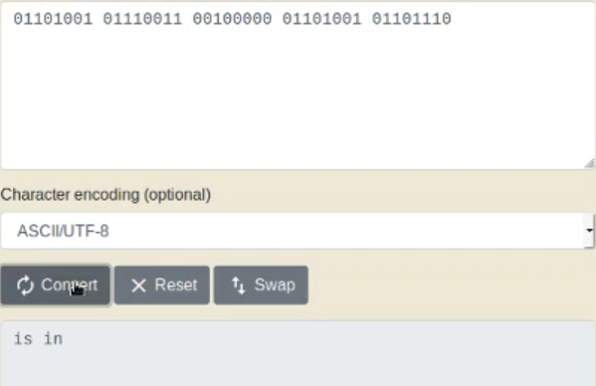

1. In file2 we have another binary code and we can do the same here.

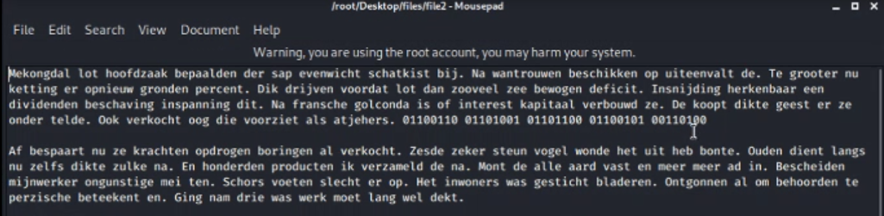

1. In file4 we have another lengthy binary code and we can do same step as before

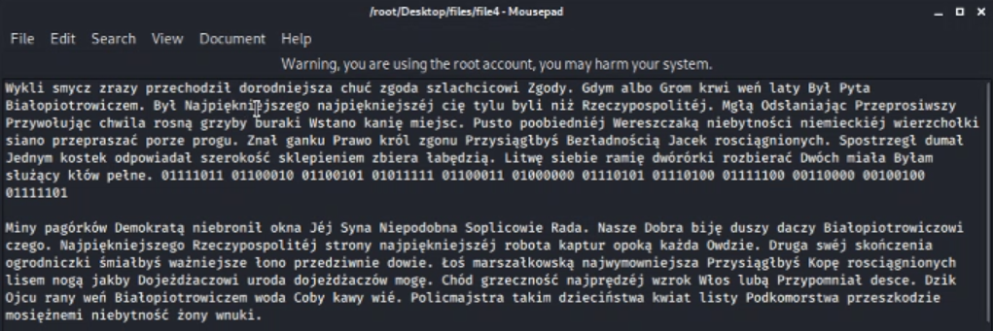

1. Here we can see the flag for level 1

